**Дата**: 21.11.2024

**Клас**: 5-АБ

**Предмет**: англійська мова

**Тема:** Мій улюблений рецепт.

**Мета:** : формувати навички вживання лексичних одиниць по темі; удосконалювати навички читання, аудіювання й усного монологічного мовлення; розвивати пізнавальні інтереси учнів; виховувати інтерес до самостійного пошуку потрібної інформації, а також загальну культуру учнів.

**Вчитель**: Руда Д.В.

Хід уроку

1.Greeting

Good afternoon, guys! I’m glad to see you. Are you ready to start our

lesson? All set?

2. Wаrm up / Listening

Уважно слухати аудіо трек і запам’ятовувати подані слова <https://www.youtube.com/watch?v=oqfh5i5Zfcs> .

1. Pour : The girl is pouring some tea into the cup

2. Sip: She is sipping the hot tea slowly

3. Toast: Let's toast some bread in the toaster

4. Spread: I like to spread butter on my toast in the morning

5. Squeeze: She is squeezing a lemon

6. Break: Break the eggs into a glass bowl

7. Weigh: Weigh the flour on the scale

8. Measure: You can measure the water with a measuring cup

9. Mix: Mix the batter together until it is smooth

10. Put: Put the frying pan on the stove

11. Make: She's making pancakes

12. Layer: Layer the pancakes on the plate

13. Wash: Be sure to wash the fruits before eating them

14. Peel: Tom is peeling the potatoes dice dice the potatoes into cubes

15. Dip: I like to dip my fries in ketchup

3. Speaking

What are your favourite fruits?

What are your favourite vegetables?

What are your favourite herbs and spices?

Do you prefer sweet or savoury foods?

Do you eat meat or are you a vegetarian?

What are your favourite pizza toppings?

What foods can’t you stand?

When was the last time you ate out? Would you go back to that restaurant?

Do you have any favourite restaurants? What kind of food do they serve?

Which is your favourite foreign cuisine? And how often do you eat it?  Do you ever prepare it yourself?

What are the advantages and disadvantages of fast food?

Do you enjoy cooking? What dishes do you typically make?

What’s your best dish? What are the ingredients and how do you make it?

What’s your favourite dessert?

What are your favourite cakes or biscuits?

4. Повторення

Повторення reflexive pronouns :

<https://wordwall.net/ru/resource/14608372/reflexive-pronouns>

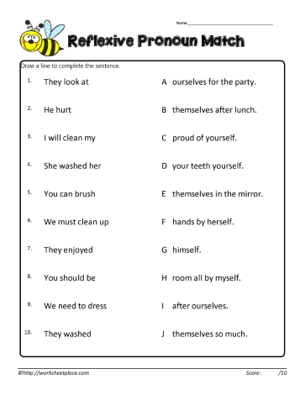

5. Writing

Виконати вправу подану нижче на закріплення знань з теми.

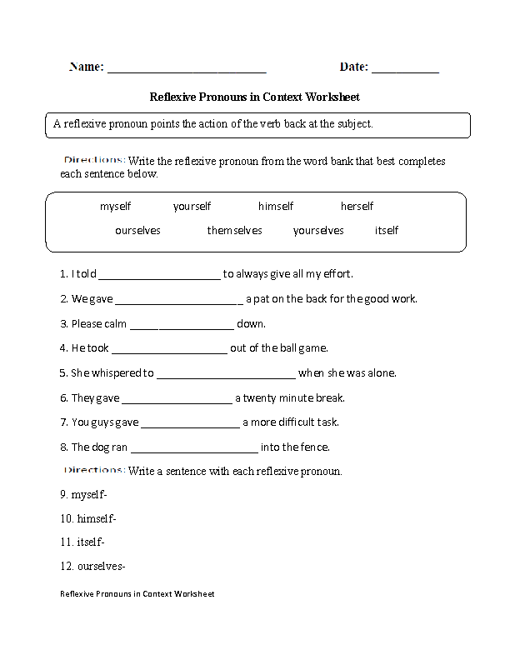

6. Homework

1. Виконати вправу подану нижче.

